

6/9/2024

Anushka Pandey

BBA 1ST Year

**Practical Report**

**on**

# Data Visualization and Dashboard Creation

### Using Excel and Looker Studio

**Submitted by:**

**Anushka Pandey**

**Sumitted to:**

**Mr.Rahul Gupta sir**

**Table of Contents**

1. Introduction
2. Data Source Introduction
3. Data Analytical Questions
4. Excel Dashboard
   * Course Popularity (Bar Chart)
   * Training Type Distribution (Donut Chart)
   * Top 12 Training Programs by Revenue (Stacked Bar Chart)
   * Participant Enrollment Over Time (Time Graph)
   * Revenue by Course (Bar Chart)
5. Looker Studio Dashboard
   * Geographic Representation of Orders
   * Orders by Region (Donut Chart)
   * Orders by Segment (Pie Chart)
   * Orders by Category (Stacked Bar Chart)
   * Orders by City (Bar Graph)
   * Orders by Quantity (Year-wise and Month-wise Line/Bar Graphs)
6. Summary
7. References
8. Appendices

# **Create a Data Analytics Dashboard using excel**

## **Data Source Introduction**

## **ABC Traning Center**

## 

NO. of row -21802

NO. of columns- 8

Columns name

1. Training ID
2. Training Date
3. Training Name
4. Package Price
5. Participants
6. Total Revenue
7. Training Location
8. Training Type

# Data Analytical Question

1. What are the most popular cources among the participants?
2. What type of Traning is most sold ( online or offline )?
3. What are the Top 12 Traning course with Highest revenue?
4. What are number of participant who got engaged with the Traning center over the years?
5. What is the revenue generated with each course?

**PIVOTE TABLE And GRAPHS**

**1.**

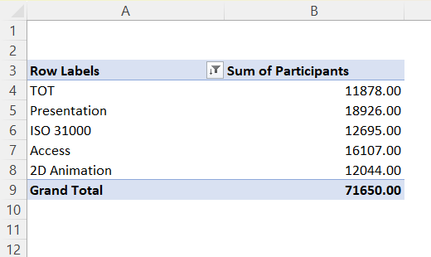

**2**.

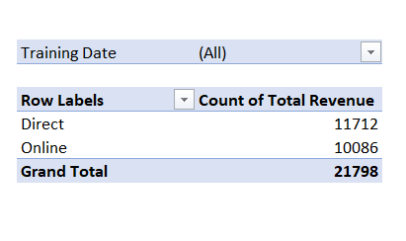

**3.**

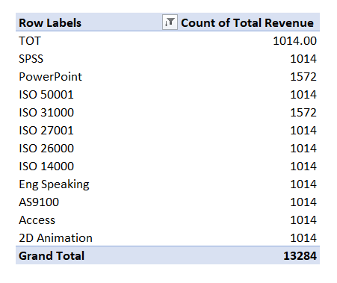

**4.**

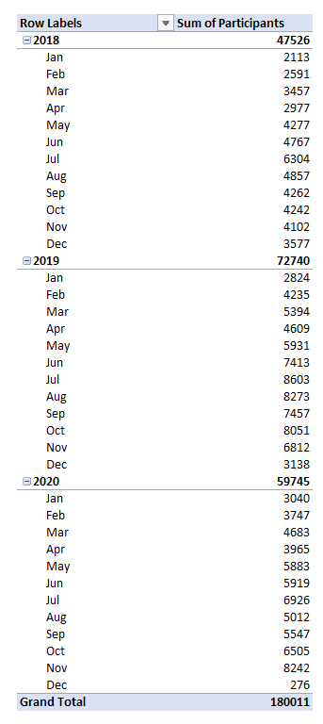

**5.**

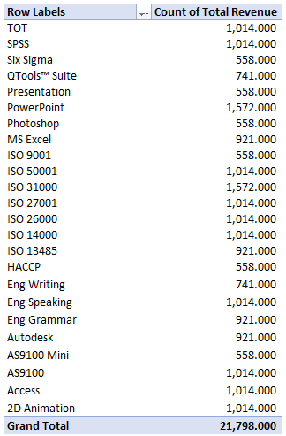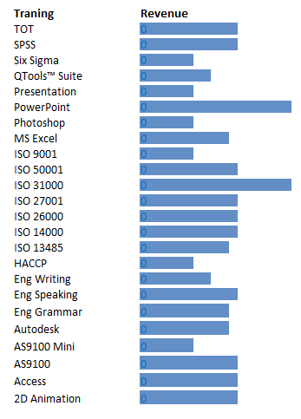

# **SALES DASHBOARD OF ABC TRANING CENTER**

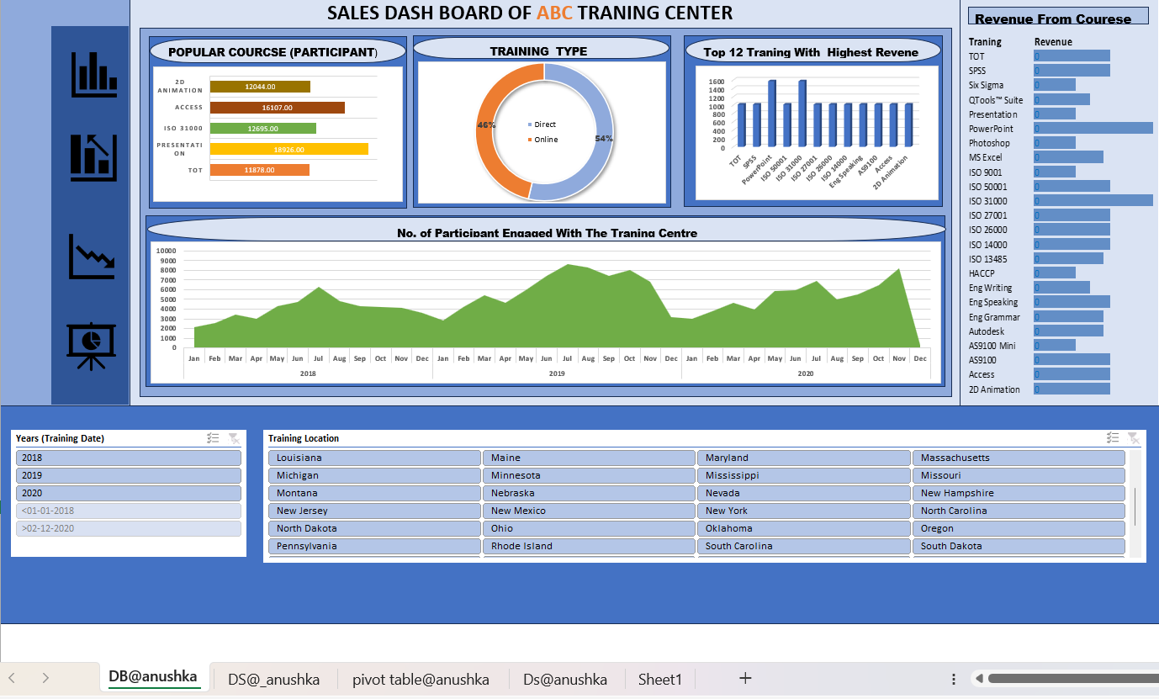

**Summary for ABC Training Centre Dashboard**

**Dashboard 1: Course Popularity and Training Analysis**

**Popular Courses (Bar Chart):**

**Description:** This bar chart displays the most popular courses offered by ABC Training Centre.

**Key Insights:** Identifies which courses attract the most participants, aiding in understanding market demand.

T**raining Type Distribution (Donut Chart):**

**Description:** This donut chart illustrates the distribution of training types, whether online or offline.

**Key Insights**: Provides a clear comparison of the preference for online versus offline training formats among participants.

**Top 12 Training Programs by Revenue (Stacked Bar Chart):**

**Description:** A stacked bar chart showcasing the top 12 training programs that generate the highest revenue.

**Key Insights:** Highlights the most profitable courses, segmented by different contributing factors such as course duration, level, or other relevant criteria.

**Participant Enrollment Over Time (Time Graph):**

**Description:** This time graph presents the number of participants enrolled at the training center on a month-wise basis over the past years.

**Key Insights:** Trends in enrollment numbers, seasonal variations, and growth patterns over time.

**Revenue-wise Courses (Bar Chart):**

**Description:** A bar chart representing the revenue generated by each course.

**Key Insights:** Offers a detailed comparison of how much revenue each course brings in, useful for financial planning and course development.

This dashboard effectively provides an overview of the training center's course popularity, training type preferences, revenue-generating courses, enrollment trends, and overall financial performance. These insights can be instrumental in strategic planning, marketing, and improving the training programs offered by ABC Training Centre.

# Create a Data Analytics Dashboard using Lookerstudio

**Data Introduction**

**Data source – Logistics data for US superstore**

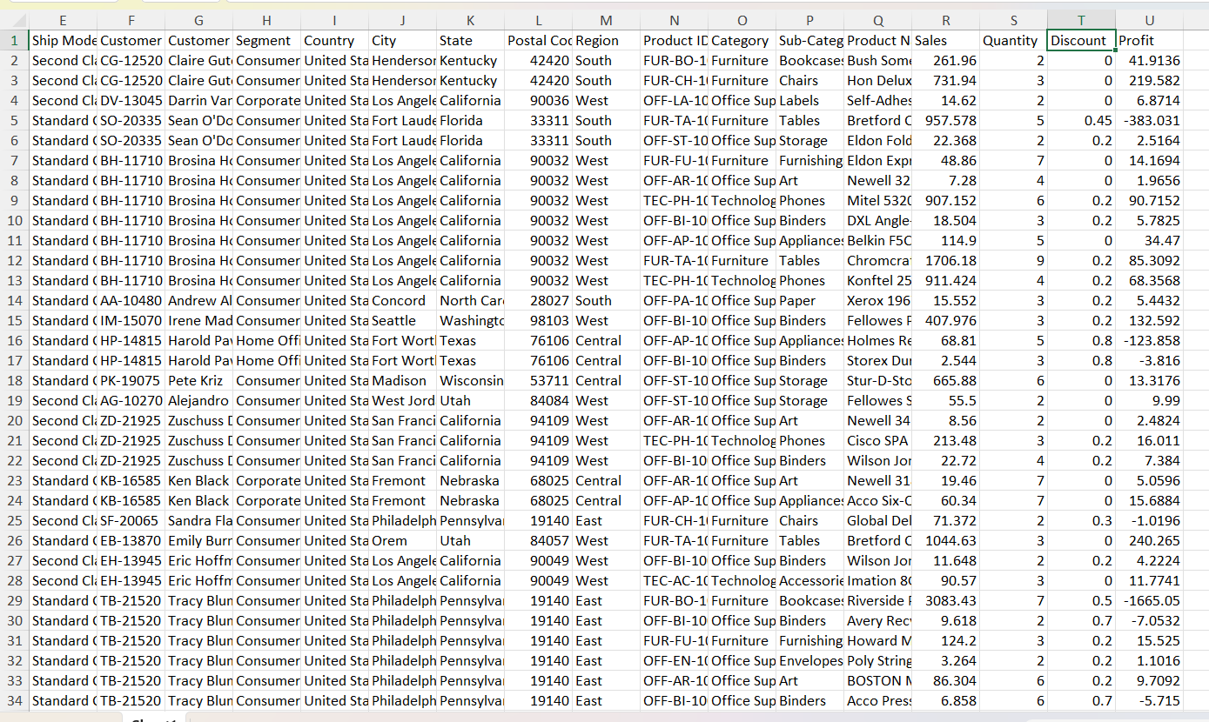

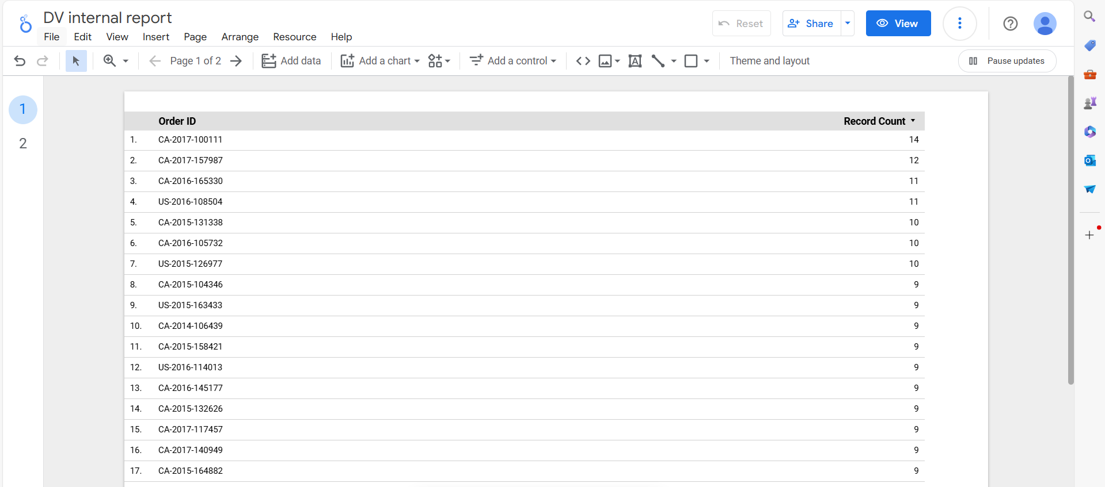

# Data Analytical Question

1. What is the geographic representation of orders placed from different citys ?
2. What are the percentage of orders by region?
3. What are the percentage of orders by segment?
4. How many orders were placed by there category?
5. What number of orders were placed city wise ?
6. What Quantity of orders were sold in each year?
7. What Quantity of orders were sold month wise of years?

# **LOGISTICS DASHBORD OF US BASED SUPERSTORE**

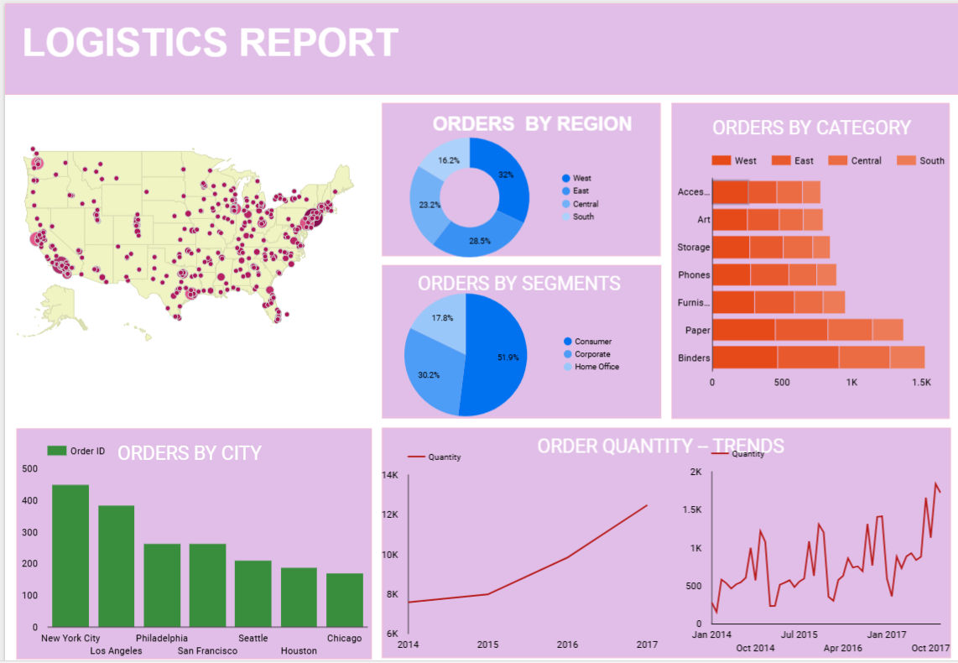

**Logistics Superstore Dashboard Summary**

**1. Geographic Location**

**Description:** The geographic location of the logistics superstore is plotted on a geo chart.

**Insight:** This provides a visual representation of where the superstore is located within the US, highlighting the geographical reach and potential logistical considerations.

**2. Orders by Region**

**Chart Type: Donut Chart**

**Description:** Displays the distribution of orders across different regions.

**Insight:** Allows for a quick comparison of which regions have the highest and lowest number of orders, aiding in regional performance analysis and strategy planning.

**3. Orders by Segment**

**Chart Type: Pie Chart**

Description: Shows the breakdown of orders by different customer segments.

**Insight:** Helps identify the most lucrative customer segments, which can inform targeted marketing and sales strategies.

**4. Orders by Category**

**Chart Type: Stacked Bar Chart**

**Description:** Illustrates the number of orders divided by product categories.

**Insight:** Enables an understanding of which product categories are most popular and their contribution to total orders, supporting inventory and merchandising decisions.

**5. Orders by City**

**Chart Type: Bar Graph**

**Description:** Depicts the number of orders from various cities.

**Insight:** Highlights key urban areas with high order volumes, which can inform regional distribution strategies and resource allocation.

**6. Orders by Quantity**

**a) Year-wise**

**Chart Type: Line Graph (or Bar Graph)**

**Description:** Tracks the quantity of orders over the years.

**Insight:** Reveals trends and growth patterns over time, useful for long-term planning and forecasting.

**b) Month-wise**

**Chart Type: Line Graph (or Bar Graph)**

**Description:** Shows the quantity of orders on a monthly basis within a year.

**Insight:** Identifies seasonal trends and monthly fluctuations, aiding in operational adjustments and marketing campaigns.

**Summary**

The Logistics Superstore dashboard provides a comprehensive overview of the store's performance across various dimensions, from geographic distribution and regional orders to customer segments and product categories. By visualizing orders by city and analyzing order quantities both year-wise and month-wise, the dashboard delivers valuable insights that support strategic decision-making, operational efficiency, and targeted marketing efforts.